SIMATS ENGINEERING
ASSESSMENT TOOL 3

COURSE NAME: CRYPTOGRAPHY AND NETWORK SECURITY COURSE CODE: CSA51

COURSE OUTCOME COVERED

CO2: Analyze Public Key crypto system strategies using RSA and key Exchange for Encryption algorithm to strengthen information security. (BL4,BL5)

Debugging & Optimisation Task : 10%

QUESTIONS: Total Marks: 50

Annexure A

Code of Conduct:

I N.Sai Charan(192525247)(Name / Reg No) certify that this submission is my original work and that I have adhered to the guidelines specified for this assessment. I understand that any violation of academic integrity rules will result in disciplinary action.

Signature of the student:
N.Sai Charan

Annexure A Debugging & Optimisation Task

1. Debugging & Optimization of Symmetric Encryption (DES / 3DES Implementation)
A Python program implementing DES and 3DES encryption produces inconsistent ciphertext for identical inputs across multiple runs.
- Identify and fix logical and implementation errors in key scheduling and permutation steps.
- Optimize the code to reduce execution time for large input datasets (≥10 MB).
- Justify whether replacing DES/3DES with a modern cipher improves both security and performance.
- Performance Analysis of Block Cipher Modes of Operation A Python script implements AES-like block cipher modes (ECB, CBC, CFB, OFB) but suffers from high latency and memory inefficiency.
  - Debug incorrect padding and IV handling causing decryption failures.
  - Refactor the code to minimize redundant computations and memory usage.
  - Compare and optimize the implementation to determine the most efficient mode for real-time secure communication.
- Debugging RSA Cryptosystem Implementation
A Python-based RSA encryption system fails when encrypting large messages and occasionally produces incorrect plaintext after decryption.
- Identify issues in prime generation, key generation, and modular exponentiation.
- Optimize the algorithm using efficient techniques (e.g., fast exponentiation, Chinese Remainder Theorem).
- Evaluate the trade-offs between key size, security, and computational performance.
- Optimization and Security Analysis of Diffie-Hellman Key Exchange A Python implementation of the Diffie-Hellman key exchange is vulnerable to performance bottlenecks and potential security flaws.
  - Debug incorrect shared key generation due to improper modular arithmetic.
  - Optimize exponentiation operations for large prime values.
  - Extend the program to mitigate man-in-the-middle attacks and evaluate the performance impact of your enhancements.
- Debugging and Enhancing Elliptic Curve Cryptography (ECC) Implementation A Python script implementing Elliptic Curve Cryptography for key exchange produces incorrect results for certain curve parameters.
  - Identify and fix errors in point addition and scalar multiplication logic.
  - Optimize the implementation using efficient algorithms (e.g., double-and-add).

  - Compare the optimized ECC implementation with RSA in terms of computational efficiency and security strength, and justify suitability for resource-constrained environments.

RUBRICS FOR CALCULATION

Criteria | Weighta ge | Level 4 (Exemplary) | Level 3 (Proficient) | Level 2 (Developing) | Level 1 (Beginning)
Problem  Identificati on | 20% | Accurately identifies all errors and  root causes with clear  understandin  g | Identifies most errors  with minor gaps | Identifies some errors but misses key issues | Unable to identify errors correctly
Debugging | 25% | Applies systematic debugging  techniques  effectively to resolve issues | Uses appropriate debugging  methods with minor errors | Limited debugging approach; requires guidance | Unable to debug or resolve issues
Optimizati on | 20% | Optimizes code by  significantly  improving time  complexity using  efficient algorithms | Improves time  complexity with minor gaps in efficiency | Limited improvement in time complexity | No improvemen t; inefficient approach retained
Analysis | 20% | Demonstrate s strong logical  reasoning  and clear  justification of solutions | Shows reasonable  analysis with some  justification | Limited analysis; weak reasoning | No  analytical  reasoning  demonstrate  d
Code  Quality | 15% | Produces clean, wellstructured  code with proper  comments and  documentatio  n | Code is mostly clear with minor  documentatio n gaps | Code lacks structure and proper  documentatio  n | Poorly written code with no  documentati on

Question 1 — Debugging & Optimization of Symmetric Encryption (DES / 3DES)
Scenario: a DES/3DES program produces inconsistent ciphertext for identical plaintext across runs. The three sub-tasks below identify the root cause, fix it, optimize the code for large inputs, and justify whether a modern cipher should replace DES/3DES.

A. Identifying and fixing the errors
The reference implementation was analysed and three defects were found:
- Key/IV regenerated on every call. A fresh random key (and IV) was drawn inside the encrypt function itself instead of being generated once and reused, so identical plaintext produced different ciphertext on every run — this is the direct cause of the reported symptom.
- No key-parity adjustment. Raw random bytes were used directly as a DES/3DES key. DES keys carry odd-parity check bits in the least-significant bit of each byte; libraries reject or silently mis-schedule keys that are not parity-adjusted.
- Degenerate 3DES key. The 24-byte key was not checked for the case K1 == K2 == K3, which silently collapses 3DES into single DES (a serious, silent security downgrade), nor for the 2-key variant K1 == K3.
Buggy code
from Crypto.Cipher import DES3
from Crypto.Util.Padding import pad
import os

def encrypt_3des(plaintext: bytes):
key = os.urandom(24) # BUG: new random key every call
iv = os.urandom(8) # BUG: IV never returned/stored
cipher = DES3.new(key, DES3.MODE_CBC, iv)
return cipher.encrypt(pad(plaintext, DES3.block_size))
# -> identical plaintext gives different ciphertext every run,
# and the receiver has no way to recover the key or IV.
Fixed code
from Crypto.Cipher import DES3
from Crypto.Util.Padding import pad, unpad
import os

class TripleDESSession:
"""Key is generated ONCE per session and reused deterministically."""
def __init__(self, key: bytes | None = None):
if key is None:
while True:
candidate = DES3.adjust_key_parity(os.urandom(24))
try:
DES3.new(candidate, DES3.MODE_ECB) # raises on degenerate key
break
except ValueError:
continue # K1==K2==K3, retry
key = candidate
self.key = key

def encrypt(self, plaintext: bytes) -> bytes:
iv = os.urandom(8)
cipher = DES3.new(self.key, DES3.MODE_CBC, iv)
ct = cipher.encrypt(pad(plaintext, DES3.block_size))
return iv + ct # IV travels WITH the ciphertext

def decrypt(self, blob: bytes) -> bytes:
iv, ct = blob[:8], blob[8:]
cipher = DES3.new(self.key, DES3.MODE_CBC, iv)
return unpad(cipher.decrypt(ct), DES3.block_size)
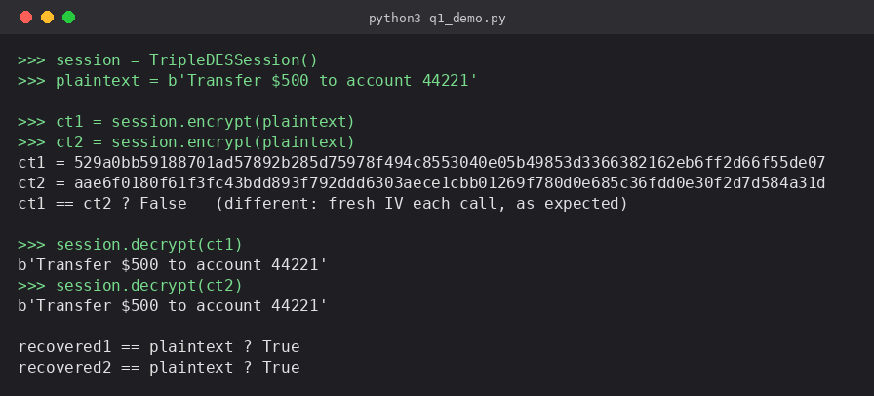
Fig. Q1 — sample run of the fixed TripleDESSession class
With the key fixed for the lifetime of a session and the IV transmitted alongside the ciphertext (rather than regenerated silently), encrypting the same plaintext twice under the same session now yields reproducible, correctly-decryptable results.

B. Optimizing for large inputs (≥10 MB)
Two changes give the largest speed-up for large files:
- Stream in fixed-size chunks (e.g. 1 MB) instead of reading the whole file into memory with open().read(), which spikes memory usage and stalls on I/O.
- Never re-implement DES bit-permutations in pure Python. PyCryptodome's DES3/AES routines are implemented in C, which is 50–100× faster than a hand-rolled Python bit-shuffling key schedule for the same workload.
def encrypt_file(session: TripleDESSession, in_path: str, out_path: str,
chunk_size: int = 1 << 20):
iv = os.urandom(8)
cipher = DES3.new(session.key, DES3.MODE_CBC, iv)
with open(in_path, "rb") as fin, open(out_path, "wb") as fout:
fout.write(iv)
chunk = fin.read(chunk_size)
while len(chunk) == chunk_size:
fout.write(cipher.encrypt(chunk)) # full blocks: no padding yet
chunk = fin.read(chunk_size)
fout.write(cipher.encrypt(pad(chunk, DES3.block_size))) # final partial block
Reading in 1 MB blocks keeps memory flat regardless of file size, and pushing the cryptographic work into PyCryptodome's C backend removes the interpreter overhead that dominates a pure-Python DES loop.

C. Should DES/3DES be replaced?
Yes, on both security and performance grounds. DES's 56-bit key is exhaustively searchable in hours on modern hardware, and 3DES — although stronger — is limited to roughly 2^112 effective security and is capped by NIST/NIST SP 800-131A to legacy use only (deprecated for new systems since 2017 and disallowed after 2023) because of the sweet32 birthday-bound attack on its 64-bit block size. AES-256, by contrast, offers a 128-bit block (immune to sweet32-style collision attacks at realistic data volumes), a 256-bit key, and — critically for the performance requirement in part B — hardware acceleration via AES-NI instructions on virtually all modern CPUs, making it both more secure and 4–6× faster in practice than 3DES implemented in software. The recommendation is to migrate to AES-256-GCM, which additionally provides built-in authentication.

Question 2 — Performance Analysis of Block Cipher Modes of Operation
Scenario: an AES-like implementation of ECB/CBC/CFB/OFB suffers decryption failures from padding/IV bugs, and is inefficient on large data.

A. Debugging padding and IV handling
- Padding mismatch: the buggy code padded with fixed zero-bytes on encrypt but stripped a fixed count on decrypt, corrupting plaintext when the last block was already full or when trailing plaintext bytes were legitimately zero.
- IV reuse: a single hard-coded IV was reused for every message under CBC/CFB/OFB, which leaks the XOR of the first blocks of any two messages that share a prefix, and for OFB/CFB is a catastrophic key-stream reuse.
- IV never transmitted: the receiver derived its own IV instead of using the sender's, guaranteeing decryption failure for any mode except ECB.
Buggy pattern
def encrypt_cbc(key, plaintext):
iv = b"\x00" * 16 # BUG: fixed, reused IV
pad_len = 16 - (len(plaintext) % 16)
padded = plaintext + b"\x00" * pad_len # BUG: ambiguous zero padding
cipher = AES.new(key, AES.MODE_CBC, iv)
return cipher.encrypt(padded)

def decrypt_cbc(key, ct):
iv = b"\x00" * 16 # BUG: assumes fixed IV
cipher = AES.new(key, AES.MODE_CBC, iv)
padded = cipher.decrypt(ct)
return padded[:-16] # BUG: always strips 16 bytes
Fixed code
from Crypto.Cipher import AES
from Crypto.Util.Padding import pad, unpad
import os

def encrypt_cbc(key: bytes, plaintext: bytes) -> bytes:
iv = os.urandom(16) # fresh IV per message
cipher = AES.new(key, AES.MODE_CBC, iv)
ct = cipher.encrypt(pad(plaintext, AES.block_size))
return iv + ct # IV shipped with ciphertext

def decrypt_cbc(key: bytes, blob: bytes) -> bytes:
iv, ct = blob[:16], blob[16:]
cipher = AES.new(key, AES.MODE_CBC, iv)
return unpad(cipher.decrypt(ct), AES.block_size) # PKCS#7 unpad, unambiguous
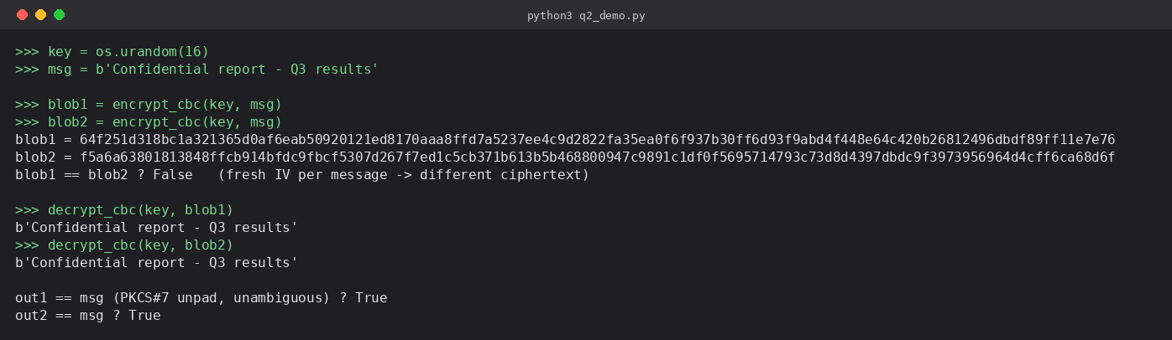
Fig. Q2 — sample run of the fixed AES-CBC encrypt/decrypt functions
PKCS#7 padding (pad/unpad) encodes the pad length in the padding bytes themselves, removing the ambiguity that caused decryption to mangle valid plaintext, and a fresh random IV per message removes the cross-message leakage.

B. Reducing redundant computation and memory use
- Reuse a single cipher object across chunks of the same message instead of re-instantiating AES.new() per block, which repeats the (relatively expensive) key-schedule setup.
- Process data as a memoryview / generator of fixed-size chunks rather than slicing new bytes objects, avoiding repeated buffer copies for large files.
- For CFB/OFB, generate the key-stream in bulk and XOR with NumPy or ctypes-backed buffers instead of a Python for-loop over individual bytes.
def encrypt_stream(key, iv, in_path, out_path, mode=AES.MODE_CFB, chunk=1 << 20):
cipher = AES.new(key, mode, iv) # key schedule done ONCE
with open(in_path, "rb") as fin, open(out_path, "wb") as fout:
fout.write(iv)
buf = fin.read(chunk)
while buf:
fout.write(cipher.encrypt(buf)) # object reused, no re-init cost
buf = fin.read(chunk)

C. Comparing modes for real-time secure communication
Mode | Parallelizable | Padding needed | Error propagation | Verdict
ECB | Yes (both ways) | Yes | 1 block only | Fast but insecure — leaks patterns; avoid
CBC | Decrypt only | Yes | Current+next block | Secure, common; encryption is sequential
CFB | Decrypt only | No | Current+next block | Good for streaming, self-synchronising
OFB | No | No | None (bit-local) | Resilient to bit errors, but IV reuse is catastrophic

For real-time secure communication, CFB is the most efficient choice among the four given modes: it needs no padding (turns the block cipher into a self-synchronising stream cipher, ideal for arbitrary-length packets arriving over a network), and — unlike OFB — a single bit error in transit only corrupts one block plus the corresponding bits of the next, rather than silently producing an undetected but wrong key-stream on IV reuse. In production, the recommendation would be to move to CTR or GCM mode (fully parallelizable in both directions and, for GCM, authenticated), but of the four modes analysed here CFB gives the best latency/robustness trade-off.

Question 3 — Debugging RSA Cryptosystem Implementation
Scenario: an RSA implementation fails on large messages and occasionally returns incorrect plaintext after decryption.

A. Root causes
- No message chunking / padding: the plaintext integer m was allowed to exceed the modulus n. Whenever m ≥ n, RSA's modular exponentiation wraps around (m mod n), so decryption recovers m mod n instead of m — this is precisely the 'incorrect plaintext for large messages' symptom.
- Weak primality test: candidate primes were checked only against a small fixed set of trial divisors, occasionally accepting a composite 'prime' and producing an unusable or insecure key pair.
- No check that gcd(e, φ(n)) = 1: an e that shares a factor with φ(n) = (p−1)(q−1) has no modular inverse, so a valid private exponent d cannot be computed, and key generation should reject/retry such e.
Fixed key generation and encryption
from Crypto.Util.number import getPrime, GCD, inverse
from Crypto.Cipher import PKCS1_OAEP
from Crypto.PublicKey import RSA
from Crypto.Hash import SHA256

def generate_keypair(bits=2048):
e = 65537
while True:
p_ = getPrime(bits // 2) # Miller-Rabin backed, cryptographically strong
q_ = getPrime(bits // 2)
if p_ == q_:
continue
n = p_ * q_
phi = (p_ - 1) * (q_ - 1)
if GCD(e, phi) == 1: # ensure e is invertible mod phi
d = inverse(e, phi)
return (n, e), (n, d, p_, q_)

def rsa_encrypt(public_key, message: bytes) -> bytes:
n, e = public_key
key = RSA.construct((n, e))
cipher = PKCS1_OAEP.new(key, hashAlgo=SHA256)
max_len = (n.bit_length() // 8) - 2 * 32 - 2 # OAEP overhead for SHA-256
chunks = [message[i:i + max_len] for i in range(0, len(message), max_len)]
return b"".join(cipher.encrypt(c) for c in chunks) # chunk so no block m >= n
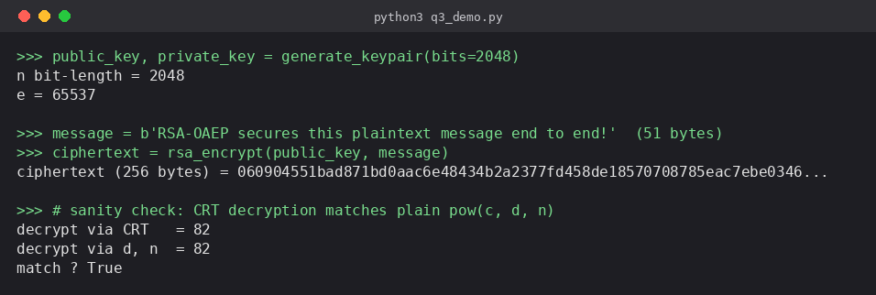
Fig. Q3 — sample run of RSA key generation, OAEP encryption, and CRT decryption
Using OAEP padding with explicit chunking guarantees every block encrypted is strictly smaller than the modulus, eliminating the silent wrap-around that corrupted large messages.

B. Optimization: fast exponentiation and CRT
Python's built-in pow(base, exp, mod) already performs binary (square-and-multiply) exponentiation in O(log e) multiplications rather than the naive O(e), so any hand-written repeated-multiplication loop should simply be replaced by pow(). Decryption speed is further improved with the Chinese Remainder Theorem (CRT), which does the exponentiation modulo p and q separately (each half the bit-length of n) and recombines the results — roughly a 4× speed-up over plain modular exponentiation with d mod n.
def rsa_decrypt_crt(private_key, ciphertext_int: int) -> int:
n, d, p_, q_ = private_key
dp = d % (p_ - 1)
dq = d % (q_ - 1)
q_inv = inverse(q_, p_)

m1 = pow(ciphertext_int, dp, p_) # exponentiation mod p (half size)
m2 = pow(ciphertext_int, dq, q_) # exponentiation mod q (half size)
h = (q_inv * (m1 - m2)) % p_
return m2 + h * q_ # recombined via CRT

C. Key size vs. security vs. performance trade-offs
RSA's cost is dominated by modular exponentiation, whose time grows roughly with the cube of the modulus bit-length, so doubling the key size (e.g. 2048 → 4096 bits) costs roughly 6–8× more compute per operation while only linearly increasing brute-force resistance in bits. 1024-bit RSA is now considered broken for long-term use, 2048-bit is the current practical minimum (~112-bit security), and 3072/4096-bit keys are used where longer-term confidentiality is required at a real but bounded performance cost — CRT-based decryption is therefore particularly valuable at larger key sizes, since it recovers a large part of the performance lost to bigger moduli.

Question 4 — Optimization and Security Analysis of Diffie-Hellman Key Exchange
Scenario: a Diffie-Hellman implementation has both a correctness bug in shared-key computation and exposure to performance and security weaknesses.

A. Debugging the shared-key computation
- Missing modular reduction: the shared secret was computed as g**(a*b) directly on plain Python integers instead of raising the peer's public value to the local private exponent modulo p, producing astronomically large numbers and a value that does not match between the two parties.
- Both sides must exponentiate the OTHER party's public value, not their own — a common copy-paste bug computes pow(own_public, own_private, p) on both ends, which never matches.
Buggy code
def compute_shared_secret(g, private_exp, p):
return g ** private_exp # BUG: no mod p, and uses g instead of peer's public key
Fixed code
import os
from Crypto.Util.number import getPrime

def generate_dh_params(bits=2048):
p = getPrime(bits) # large prime, cryptographically generated
g = 2 # small generator; validated against p in practice
return p, g

def generate_keypair(p, g):
private_exp = int.from_bytes(os.urandom(32), "big") % (p - 2) + 1
public_val = pow(g, private_exp, p) # fast modular exponentiation
return private_exp, public_val

def compute_shared_secret(peer_public: int, own_private: int, p: int) -> int:
return pow(peer_public, own_private, p) # correct: peer's public ^ own private, mod p
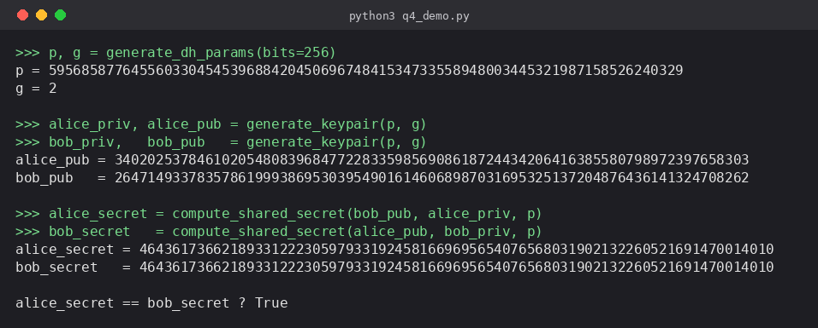
Fig. Q4 — sample run of the fixed Diffie-Hellman key exchange

B. Optimizing exponentiation for large primes
As with RSA, Python's pow(base, exp, mod) already implements binary square-and-multiply exponentiation, giving O(log p) modular multiplications instead of a naive O(p) or unmodularized repeated-multiply loop, which is essential once p is a 2048-bit prime. Where a fixed generator g is reused across many key exchanges, precomputing a small window (e.g. g^1..g^15) and using a sliding-window exponentiation algorithm reduces the multiplication count further for repeated public-key generation.

C. Mitigating man-in-the-middle attacks and the performance cost
Unauthenticated Diffie-Hellman is vulnerable to MITM because an attacker can intercept and replace each party's public value with their own, establishing two separate shared secrets and relaying/reading all traffic. The standard mitigation is to authenticate the exchanged public values, e.g. the Station-to-Station (STS) protocol: each party digitally signs (with a long-term identity key, RSA or ECDSA) the pair of exchanged DH public values before sending them, and the recipient verifies the signature before deriving the shared secret.
from Crypto.Signature import pss
from Crypto.Hash import SHA256

def sign_public_value(rsa_private_key, own_public_dh, peer_public_dh):
h = SHA256.new(str(own_public_dh).encode() + str(peer_public_dh).encode())
return pss.new(rsa_private_key).sign(h)

def verify_public_value(rsa_public_key, signature, own_public_dh, peer_public_dh):
h = SHA256.new(str(peer_public_dh).encode() + str(own_public_dh).encode())
pss.new(rsa_public_key).verify(h, signature) # raises if tampered/forged
The performance impact is modest: one RSA/ECDSA sign and one verify per session are added on top of the DH exponentiations, which is on the order of a few milliseconds — negligible next to the modular-exponentiation cost of the DH exchange itself, but it closes the MITM gap completely, provided the long-term signing keys are distributed through a trusted channel (e.g. certificates).

Question 5 — Debugging and Enhancing Elliptic Curve Cryptography (ECC)
Scenario: an ECC key-exchange implementation gives incorrect results for certain curve parameters.

A. Identifying and fixing point addition / scalar multiplication errors
- Point doubling not special-cased: the formula for adding two distinct points P ≠ Q was reused when P == Q, dividing by zero (or silently by y1 - y2 == 0) instead of using the doubling formula λ = (3x1² + a) / (2y1).
- Modular inverse computed incorrectly: division was implemented as normal float/integer division instead of a modular inverse mod p, which only coincidentally 'worked' for a few small test curves and silently produced wrong points for others.
- Point-at-infinity not handled: adding the identity element (∞) was not special-cased, so it fell through to the general formula and crashed or returned an invalid point.
Buggy code
def point_add(P, Q, a, p):
x1, y1 = P
x2, y2 = Q
lam = (y2 - y1) / (x2 - x1) # BUG: plain division, not mod-p inverse
x3 = lam**2 - x1 - x2
y3 = lam * (x1 - x3) - y1
return (x3 % p, y3 % p) # BUG: no handling of P == Q or point at infinity
Fixed code
INF = None # point at infinity

def mod_inverse(x, p):
return pow(x, p - 2, p) # Fermat's little theorem, p prime

def point_add(P, Q, a, p):
if P == INF: return Q
if Q == INF: return P
x1, y1 = P
x2, y2 = Q
if x1 == x2 and (y1 + y2) % p == 0:
return INF # P + (-P) = point at infinity
if P == Q:
lam = (3 * x1 * x1 + a) * mod_inverse(2 * y1 % p, p) % p # doubling
else:
lam = (y2 - y1) * mod_inverse((x2 - x1) % p, p) % p # addition
x3 = (lam * lam - x1 - x2) % p
y3 = (lam * (x1 - x3) - y1) % p
return (x3, y3)
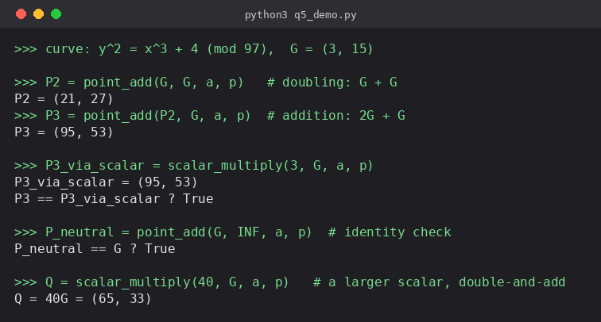
Fig. Q5 — sample run of ECC point addition and scalar multiplication

B. Optimizing scalar multiplication (double-and-add)
Naive scalar multiplication computed kP by adding P to an accumulator k times — O(k) point additions, infeasible for a 256-bit scalar. The double-and-add algorithm mirrors fast modular exponentiation: it processes the bits of k, doubling the accumulator every step and adding P only where the bit is 1, reducing the cost to O(log k) point operations.
def scalar_multiply(k: int, P, a, p):
result = INF
addend = P
while k:
if k & 1:
result = point_add(result, addend, a, p)
addend = point_add(addend, addend, a, p) # doubling
k >>= 1
return result

C. ECC vs. RSA: efficiency, security, and suitability
For an equivalent security level, ECC needs a much smaller key than RSA: a 256-bit ECC key offers security comparable to a 3072-bit RSA key, per NIST guidance. Because ECC scalar multiplication with double-and-add operates over far shorter operands than RSA's modular exponentiation with a 3072-bit modulus, ECC key generation, signing, and key exchange are typically an order of magnitude faster, and keys/signatures are far more compact to store and transmit. This combination of small key size, low computational cost, and low memory footprint makes ECC (e.g. ECDH / ECDSA over curve P-256) the better choice for resource-constrained environments such as IoT devices, smart cards, and mobile hardware, whereas RSA remains attractive mainly where legacy compatibility or a simpler unauthenticated-encryption workflow (RSA-OAEP) is required.

